YPRL Programming Framework 2021-2025

Overview
Yarra Plenty Regional Library (YPRL) is a regional service comprising nine branch libraries located across the three Member Councils of Banyule, Nillumbik and Whittlesea. Our libraries are equipped with specialist resources, spaces, collection and equipment to facilitate hands-on learning, support literacy and encourage creative expression. We provide opportunities for our community to learn, create, connect, and live well in a fun and supported environment.
Strategic alignment
This Action Plan is informed by the three-member councils’ community, health and wellbeing, social enterprise, business and arts plans, as well as YPRL’s Library Plan 2021-2025. Our vision is:
Informed creative communities: connected, empowered and well
Our three-member councils understand the value of learning, literacy and social connection in supporting community health and wellness. This Programming Framework has been linked to council community plans and strategies and each event, activity or program has outcomes that support the Roadmap to Recovery of health and wellness, economic recovery and environmental sustainability.
Context
Every day libraries help people to read, learn, discover, relax and connect with information, people and ideas. For many of our member councils’ residents, the library is an integral part of their life and their community. More than just traditional measures of library output such as the number of loans or visits, these individual and community outcomes result from libraries helping people to improve their knowledge and skills, connect with one another or change attitudes and behaviours.
YPRL library programs provide engagement, enrichment, and connection to our communities, and activate our library spaces. YPRL programs:
- are creative, innovative, and responsive to community needs
- have a regional focus, to make the most of public funding and to provide services to our whole community
- use partnerships to increase our capabilities, capacity, and offerings
- deliver reading, learning, and community outcomes at every event
- are based on codesign and collaboration with community, councils and partners
- focus on a culture of continuous improvement and testing
- emphasise innovative approaches and look for new opportunities through professional practice, research and radical collaborations.

Program Streams
 | Stream Name | Description
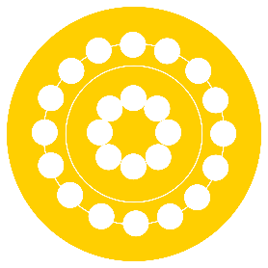 | Creating Connections | Programs that encourage the community to come together and form connections and networks, over a chat or a simple activity. Programs that let our communities celebrate and share their culture with the wider community.
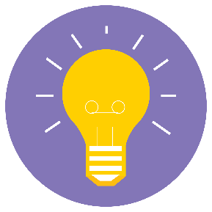 | Creative Minds | Programs to drive creativity in all sorts of ways. Craft, all things writing and literary, author talks, book clubs, Maker Space events
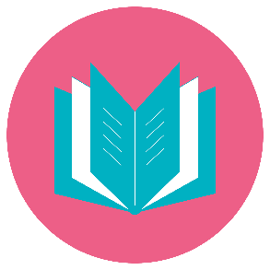 | Early Years Literacy | Programming that supports the early years, with a focus on literacy development
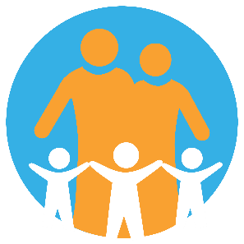 | Family Fun | Fun, free, accessible activities for the whole family, or for kids after school.
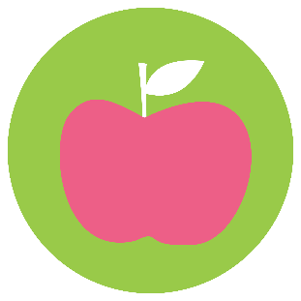 | Growing Healthy Lives | Sustainability, environment, and gardening programs, including food production and food security. Health & health literacy.
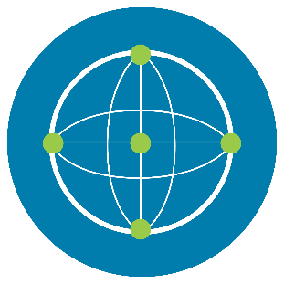 | Learning Technology | Activities to challenge and empower you in the areas of Science, Technology, Engineering, and Maths. Including tech help and elearning as well as kids’ events.
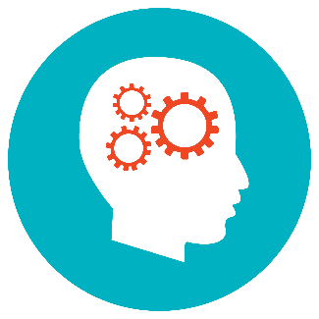 | Life Skills | Financial literacy, life skills, job readiness and back to work programs, lifestyle, mental health
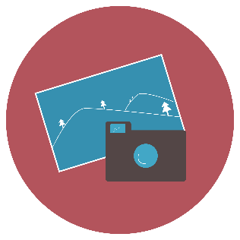 | Local and Family History | Supporting research skills for new and established historians and genealogists, with speakers, walks, and more.
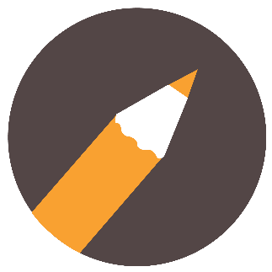 | Local Writers | Writing groups, local authors, Booklovers, events that get everybody writing
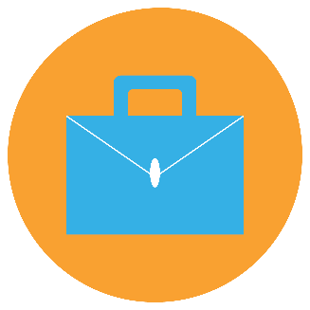 | Small Business Support | Programs and networking opportunities to strengthen and support local small businesses, new and established.

Sustainable Development Goals
YPRL supports and contributes to the delivery of the Sustainable Development Goals (SDG) understanding the important role libraries play in the international drive for greater social equality, improved economic prosperity and a more sustainable environmental approach. The SDGs provide a framework to demonstrate how libraries can support positive change, from quality education to reducing inequalities. This helps us to reflect on and align with other organisations to determine how we can create localised outcomes that contribute to meaningful change for the whole nation.
Our Program Streams are mapped to the SDGs as follows:
Program Stream | Sustainable Development Goals
Creating Connections | 3 Good Health and Wellbeing  5 Gender Equality  10 Reduced Inequalities  17 Partnerships for the Goals
Creative Minds | 3 Good Health and Wellbeing  17 Partnerships for the Goals
Early Years Literacy | 3 Good Health and Wellbeing  4 Quality Education  10 Reduced Inequalities  17 Partnerships for the Goals
Family Fun | 3 Good Health and Wellbeing  10 Reduced Inequalities  17 Partnerships for the Goals
Growing Healthy Lives | 2 Zero Hunger  3 Good Health and Wellbeing  6 Clean Water and Sanitation  7 Affordable and Clean Energy  11 Sustainable Cities and Communities  12 Responsible Consumption and Production  13 Climate Action  15 Life on Land  17 Partnerships for the Goals
Learning Technology | 3 Good Health and Wellbeing  4 Quality Education  7 Affordable and Clean Energy  10 Reduced Inequalities  17 Partnerships for the Goals
Life Skills | 1 No Poverty  2 Zero Hunger  3 Good Health and Wellbeing  4 Quality Education  10 Reduced Inequalities  17 Partnerships for the Goals
Local and Family History | 3 Good Health and Wellbeing  17 Partnerships for the Goals
Local Writers | 3 Good Health and Wellbeing  17 Partnerships for the Goals
Small Business Support | 3 Good Health and Wellbeing  8 Decent Work and Economic Growth  9 Industry, Innovation and Infrastructure  11 Sustainable Cities and Communities  17 Partnerships for the Goals

Evaluation methodologies
Evaluation is embedded within the Programming Framework both through a culture of reflection and through feedback from our community.
Our evaluation models use a mix of qualitative data – stories and case studies gathered from our community and quantitative data such as attendance figures, website access and collection use. Success measures will be reported against the SDGs.
Objectives and Actions
Objective | Description | Actions
Robust and balanced regional programming | YPRL programming meets the needs of our local communities, offering variety and supporting community connection. Programming is strategic and efficient on a regional scale. | This will be achieved by:  - Each branch will deliver programming across each Program Stream every quarter at minimum  - Ongoing evaluation of individual events and ongoing programs to assess whether programming is meeting community needs  - When appropriate, using the codesign methodology to design programs  - All programs and events will deliver outcomes in the areas of Knowledge and Learning, Connection, and Wellbeing, to support the Library Plan
Seek radical partnerships and collaborations | We understand the power of partnerships and the reach and benefits they bring to our communities and organisation. | This will be achieved by:  - Partnering across all branches to expand our capability to deliver events and services  - Actively seeking out new and innovative partnerships
Increase organisational and staff capability | Our staff feel confident and empowered to engage our communities. | This will be achieved by:  - Providing leadership opportunities for staff within regional programming  - Structuring opportunities for learning, such as peer to peer learning and secondments

